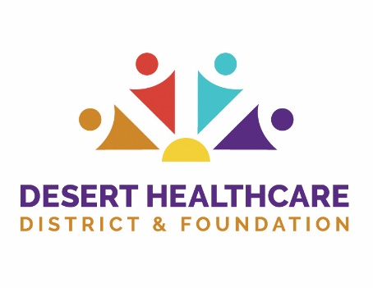

PROGRAM COMMITTEE Meeting

The meeting of the Program Committee scheduled at
12:00 p.m., Tuesday, April 14, 2020
has been canceled.

The next scheduled
Program Committee Meeting is
Tuesday, May 12, 2020 at 12:00 p.m.

