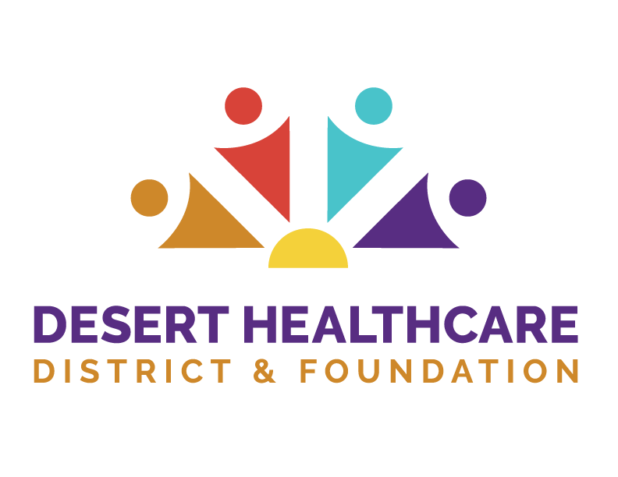
Sponsorship Request Application

POLICY #OP-17: It is the policy of the Desert Healthcare District (“District”) to define the
circumstances surrounding the sponsorship of events and conferences. The support of
local organizational events not only provides financial support to the community in line
with the mission and vision of the District, but it also provides opportunities to share and
promote the work of the District and increase visibility. (Please read the full policy for
additional information.)

Requested Dollar Amount*: _____________________________________________________
Sponsorship Levels Available: _____________________________________________________
Proposed Community Benefit: _____________________________________________________
Event Budget: _____________________________________________________
Estimated Number of Attendees: _____________________________________________________
Event Date and Location: _____________________________________________________
Pricing of Additional Tickets/Passes: __________________________________________________

Sponsorship Period: January through June
July through December

Submission: Send the completed request form to info@dhcd.org
Please copy and paste your answers into the body of the email.
Application Deadlines:
- May 31 – for sponsorship events from July through December
- November 30 – for sponsorship events from January through June
* Sponsorships up to $5,000 shall be approved at the discretion of the Chief Executive Officer (“CEO”). Sponsorships greater than $5,000 shall be presented with the sponsorship deck and requested amount to the Program Committee for review and possible recommendation of an amount to the District Board for approval.

For additional information or questions, contact info@dhcd.org

